Sensors and Control Quiz 1

Esteban Andrade 12824583

1. Camera Calibration
In order to get a quick result 11 images were took for sample of camera calibration. The first thing was to open the calibration Toolbox and extract all the grid corners.
The obtain initial parameters were :

Calibration parameters after initialization:

Focal Length: fc = [ 847.48294 847.48294 ]
Principal point: cc = [ 511.50000 383.50000 ]
Skew: alpha_c = [ 0.00000 ] => angle of pixel = 90.00000 degrees
Distortion: kc = [ 0.00000 0.00000 0.00000 0.00000 0.00000 ]

Main calibration optimization procedure - Number of images: 11
Gradient descent iterations: 1...2...3...4...5...6...7...8...9...10...11...12...13...14...15...16...17...18...19...20...done
Estimation of uncertainties...done

Calibration results after optimization (with uncertainties):

Focal Length: fc = [ 876.04095 874.83272 ] +/- [ 12.73203 12.23055 ]
Principal point: cc = [ 507.71703 430.15828 ] +/- [ 11.23956 9.20301 ]
Skew: alpha_c = [ 0.00000 ] +/- [ 0.00000 ] => angle of pixel axes = 90.00000 +/- 0.00000 degrees
Distortion: kc = [ -0.19524 0.12620 -0.00018 -0.00033 0.00000 ] +/- [ 0.02480 0.05679 0.00229 0.00274 0.00000 ]
Pixel error: err = [ 0.76467 1.07791 ]

Note: The numerical errors are approximately three times the standard deviations (for reference).

After the initial parameteres were obtained it was neccesary to adjust the results. Thus, We had to reproject on the images and recompile corners. Once this process was done. We could recalibrate the parameters. And from this we can see that the error decreases.

Calibration results (with uncertainties):

Focal Length: fc = [ 880.56611 879.77456 ] ± [ 3.87145 3.72081 ]
Principal point: cc = [ 513.81827 426.21740 ] ± [ 3.44618 2.79228 ]
Skew: alpha_c = [ 0.00000 ] ± [ 0.00000 ] => angle of pixel axes = 90.00000 ± 0.00000 degrees
Distortion: kc = [ -0.21320 0.15404 -0.00048 -0.00103 0.00000 ] ± [ 0.00761 0.01741 0.00067 0.00083 0.00000 ]
Pixel error: err = [ 0.34957 0.19403 ]

Note: The numerical errors are approximately three times the standard deviations (for reference).

As it it noticable the error is still significant. Thus, It is necessary to do the correction process again in order to increase the accuracy of the camera paramaters.

Calibration results after optimization (with uncertainties):

Focal Length: fc = [ 880.41539 879.31134 ] +/- [ 1.89598 1.82135 ]
Principal point: cc = [ 515.08222 424.14232 ] +/- [ 1.68660 1.36070 ]
Skew: alpha_c = [ 0.00000 ] +/- [ 0.00000 ] => angle of pixel axes = 90.00000 +/- 0.00000 degrees
Distortion: kc = [ -0.20231 0.14086 -0.00046 0.00039 0.00000 ] +/- [ 0.00375 0.00852 0.00033 0.00042 0.00000 ]
Pixel error: err = [ 0.15049 0.12562 ]

Note: The numerical errors are approximately three times the standard deviations (for reference).
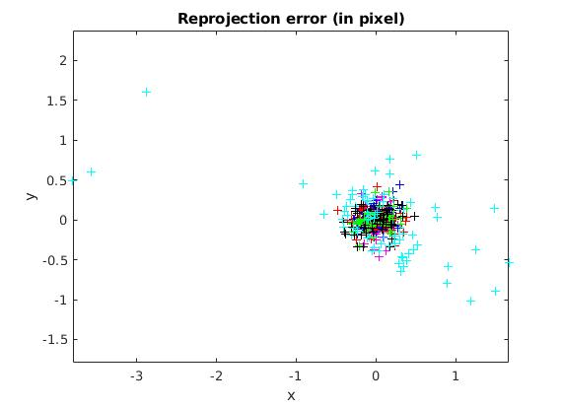

From the above image we can notice the reprojection error on the third iteration. From this it can be observed that the error gets drasctially reduced in comparison with the first and second analysis iteration

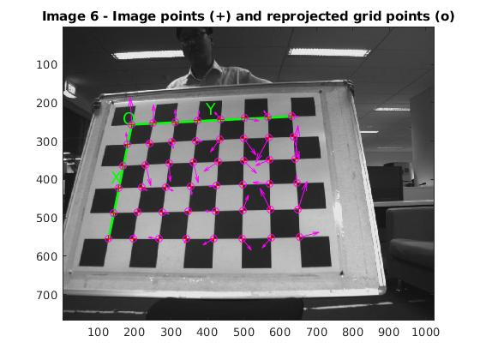

From the above image. We can see the reprojection on the image. From this we can observe the most distorsion in the image and it tries to adjust it.

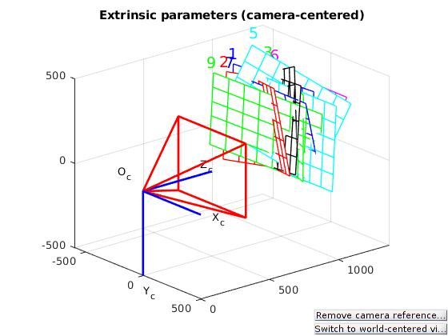

In the above image we can observe the extrinsic parameters of the camera. From this we can estimate the position of the camera and the corresponding angles and position from which the pictures were taken.

2) Project a point onto the image
Based on the obtained parameters from The Q1. The projection point (18,-32,60), into the image will be analysed using a MATLAB Script.

%Focal Lenght
fx = 880.41539;
fy = 879.31134;

%Pricical Point
px = 515.08222;
py = 424.14232;

%Homogenous Transform matrix
K = [fx,0,px;
0,fy,py;
0,0,1];
%Camera coordinate frame (3D Representation)
X_cam = [18;-32;60;1];
IM = eye(3,4);

%get point x(will be 3D point)
x = K*IM*X_cam

%to make the point into 2D (u,v) (x,y). we Divide by the third one
u = x(1)/x(3)
v = x(2)/x(3)

Based on the results we can estimate the image point (u,v). The value in 3D is obtained and the constrained to get the value for (u,v).
This is based on the following principle:
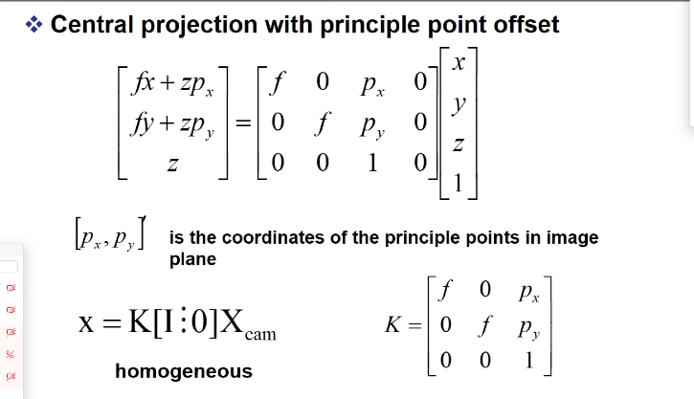

x =

1.0e+04 *

4.6752
-0.2689
0.0060

u =

779.2068

v =

-44.8237

Based on Results on the script. The Localization of the image point (u,v) with the given parameters and data set is u = 779.2068 and v = -44.8237

Note: The values to obtain the 2D values fron the 3D value of X. we have to dive the first value of the matrix by the third one, And the second one by the third one. In order to obtain the values of u and v.

ex. u = 4.6752 / 0.006 = 779.2

